A

PROJECT REPORT

ON

**“NEWSLINK”**

SUBMITTED BY – **Manish Jangid**

**Seat no. 8031**

UNDER THE GUIDANCE OF:

**Ms. Madhavi Mahajan**

SAVITRIBAI PHULE PUNE UNIVERSITY (SPPU)

MASTER OF COMPUTER APPLICATIONS



DR. D. Y. PATIL UNITECH SOCIETY’S

DR. D. Y. PATIL INSTITUTE OF MANAGEMENT AND RESEARCH, PIMPRI, PUNE-18

2023-2024

**Dr. D. Y. Patil Unitech Society**

**Dr. D.Y. PATIL INSTITUTE OF MANAGEMENT & RESEARCH, PUNE**

**Sant Tukaram Nagar, Pimpri, Pune-411018, Maharashtra, India.**

**(Approved by All India Council for Technical Education & Recognized by the Savitribai Phule Pune University)**

**CERTIFICATE**

This is to certify that **Manish Jangid** has successfully completed the project on **‘‘NewsLink’’** as a partial fulfilment of his **Master of Computer Applications (MCA)** under the curriculum of **Savitribai Phule Pune University, Pune**  for the academic year 2023-24

Ms. Madhavi Mahajan Dr. Shikha Dubey Dr. Meghana Bhilare

**Project Guide H.O.D. MCA Director**

Signature Signature

Name Name

**Internal Examiner**  **External Examiner**

Date : Date :

# Acknowledgement

The success and final outcome of **“NewsLink”** project required a lot of guidance and assistance from many people and we are extremely privileged to have got this all along the completion of our project. All that we have done is only due to such supervision and assistance and we would not forget to thank them.

We sincerely thank to the Director **Dr. Meghana Bhilare,** Associate Director **Dr. Vishal Wadajkar**, HOD **Dr. Shikha Dubey** and to my project guide **Ms.Madhavi Mahajan** and **Mrs.Kalyani Sahastrabuddhe ,** for providing us an opportunity to do the project work and give us all support and guidance which made us completes the project duty. We are extremely thankful to them for providing such a nice support and guidance, although they had busy schedule managing the corporate affairs.

We owe a deep gratitude to our project guides for taking keep interest on our project work and guiding us all along, till the completion of our project work by providing all the necessary information for developing good system.

We are thankful to and fortunate enough to get constant encouragement, support and guidance from all teaching staff which helped us in successfully completing our project work. Also, we would like to extend our sincere esteems to all staff in laboratory for the timely support.

# Table of Content

|  |  |  |
| --- | --- | --- |
| **Srno.** | **Title** | **Page no.** |
| **1** | **Introduction**   1. Problem Definition 2. System Overview 3. Definitions, Acronyms and Abbreviations 4. Project functionalities 5. Operating Environment | 5-7 |
| **2** | **Proposed System**  1)Proposed System  2)Objectives of the System  3)Feasibility Study  4)User Requirement Specification | 7-9 |
| **3** | **System Analysis &Design**   1. Use Case Diagrams 2. Class Diagram 3. Activity Diagram 4. Data Flow Diagram 5. Data Dictionary 6. ERD | 10-12 |
| **4** | **User Manual**   1. Operational Instructions 2. Input/output Screens 3. Reports | 13-17 |
| **5** | **System Limitation** | 18 |
| **6** | **Future Enhancement** | 18-19 |
| **7** | **Conclusion** | 19 |
| **8** | **Bibliography** | 20 |

**1) Introduction**

* 1. **Problem Definition**

In the era of digital communication, the need for secure and confidential information exchange has become increased rapidly. Traditional methods often fall short, prompting the development of TruCrypt Version 1.0—an Image Steganography system in Java. The problem at hand is to create a solution that allows covert communication through image files, ensuring the integrity and security of the exchanged data.

* 1. **System Overview**

TruCrypt (Version 1.0)is a Java-based Image Steganography system designed to meet the growing demand for secure information exchange. By applying advanced steganographic techniques, the system enables users to embed and extract hidden data within image files. Its standalone architecture ensures independence from external systems, offering a seamless and user-friendly experience without relying on additional software or services.

**1.3) Definitions, Acronyms and Abbreviations**

This section establishes a comprehensive glossary to foster a shared understanding among project stakeholders. It defines key terms, acronyms, and abbreviations used throughout the document, minimizing ambiguity and enhancing communication.

* **UI - User Interface**: the part of the application that allows users to interact with the application, including the design, layout, and navigation.
* **UX -** **User Experience:** the overall experience a user has when interacting with a application or other digital product, including ease of use, efficiency, and satisfaction.
* **Steganography :** Steganography is the technique of hiding data within an ordinary, nonsecret file or message to avoid detection; the hidden data is then extracted at its destination. Steganography use can be combined with encryption as an extra step for hiding or protecting data.

**1.4) Project Functionalities**

TruCrypt have a rich set of functionalities to cater to diverse user needs:

* **Image Encoding/Decoding:** The system manipulates image files to embed and extract data securely.
* **Supported Image Formats:** Compatibility with common formats such as JPEG, PNG, and BMP.
* **Encryption and Security:** Robust steganographic techniques ensure secure data handling.
* **Image Quality Preservation:** The system maintains the visual quality of the original image after data embedding.
* **Image Preview:** Users are provided with a visual preview of the modified image before finalizing the process.
* **User Authentication:** Authentication mechanisms enhance user security during system interactions.
* **Multiple Embedding Techniques:** Various methods are offered for embedding hidden data, providing flexibility.

**1.5) Operating Environment**

Developed in Java, TruCrypt Version 1.0 ensures cross-platform usability by relying on the Java Runtime Environment (JRE). This strategic choice allows the application to run seamlessly on various operating systems, making it accessible to a broader user base.

1. **Software Requirements:**

• Front End- JAVA SE 20(20.0.2)

• Operating System- Windows 7

• Tool- Apache NetBeans IDE 19

• Any file to embed

1. **Hardware Requirements:**

• Hard Disk – 2 GB.

• RAM – 1 GB.

• Processor – 300Mhz or Above.

• Mouse.

• Keyboard.

• Monitor.

**2) Proposed System**

**2.1) Proposed System**

TruCrypt Version 1.0 emerges as a comprehensive solution for secure information exchange through images. Its standalone nature enhances reliability and ease of use, positioning it as a reliable choice for individuals and organizations seeking covert communication solutions. The system's independence from external dependencies ensures consistent performance and security.

**2.2) Objectives of System**

The system's objectives are multifaceted:

1. **User Interface Module :**

* Develop a graphical user interface using Java Swing for user interaction.
* Include options for image selection, message input, and operations (embed/extract).

**2) Embedding Module :**

* Implement algorithms to embed information within the pixel values of the selected image.
* Utilize encryption techniques to secure the hidden information.

**3) Extraction Module :**

* Develop algorithms to extract hidden information from the steganographically modified image.
* Ensure accuracy and integrity in the extraction process.

**4) Image Format Support Module :**

* Implement support for various image formats to enhance compatibility.
* Integrate libraries like ImageIo for efficient image manipulation.

**5) Security Module :**

* Integrate advanced encryption techniques to secure the hidden information
* Ensure that the steganographic process leaves no traces of the embedded information.

**2.3) Feasibility study**

* **Technical Feasibility**: The first factor to consider is the technical feasibility of the project. This includes assessing the availability of the required hardware and software, as well as the technical expertise.
* **Content and Functionality:** The Application should have a clear purpose and provide relevant and up-to-date content and functionality. It is important to define the scope of the project and prioritize the features and functionality that will be included in the Application.

**2.4) User Requirements Specification**

This section provides a detailed breakdown of the specific requirements from end-users. It serves as the cornerstone for subsequent phases of the software development life cycle, offering precise guidance to developers, testers, and project managers.

**1) Embedding Data:**

* Users should be able to seamlessly embed text data into image files.
* The embedding process should be straightforward and intuitive.
* Users should have the option to choose the image file for embedding.

**2) Data Extraction:**

* Users must be able to extract hidden data from manipulated images.
* Extraction should be user-friendly and preserve the integrity of the embedded data.

**3) Intuitive Design:**

* The GUI should be visually appealing and intuitive.
* Clear controls for embedding and extracting data should be provided.

**4) Robust Cryptographic Techniques:**

* The system must employ robust cryptographic techniques to ensure the security of hidden data.
* Unauthorized access to embedded data should be prevented.

**5) Efficient Processing:**

* The system should efficiently handle embedding and extraction processes for images of varying sizes.
* Users should experience reasonable processing times.

**3) System Analysis & Design**

**3.1) Use Case Diagram**

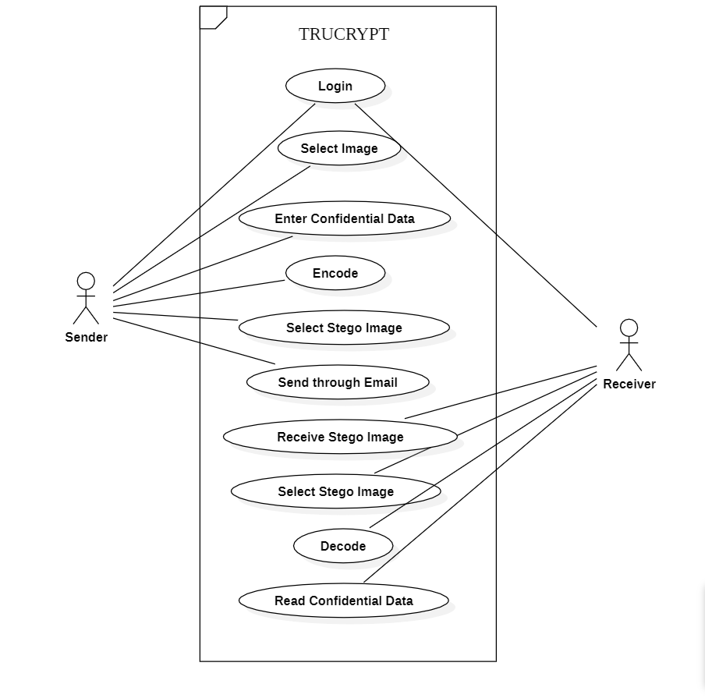

**3.2) Class Diagram**

**3.3) Activity Diagram**

**4) User Manual**

**4.1) Operational Functions:**

Comprehensive operational instructions guide users on how to interact with TruCrypt Version 1.0. This includes detailed step-by-step guidance on embedding and extracting hidden data from images, ensuring users can navigate the system effectively.

**1)Enhanced Security :** Implementation of robust encryption techniques to ensure the security

of hidden information.

**2)Usability improvement :** A user-friendly graphical interface developed using Java Swing for

seamless interaction.

**3)Maintained Image Quality :** Advanced algorithms to maintain image integrity during the

embedding process.

4**) Enhanced Compatibility**: Comprehensive support for various image formats to increase

compatibility.

**4.2) Input Output Screens**

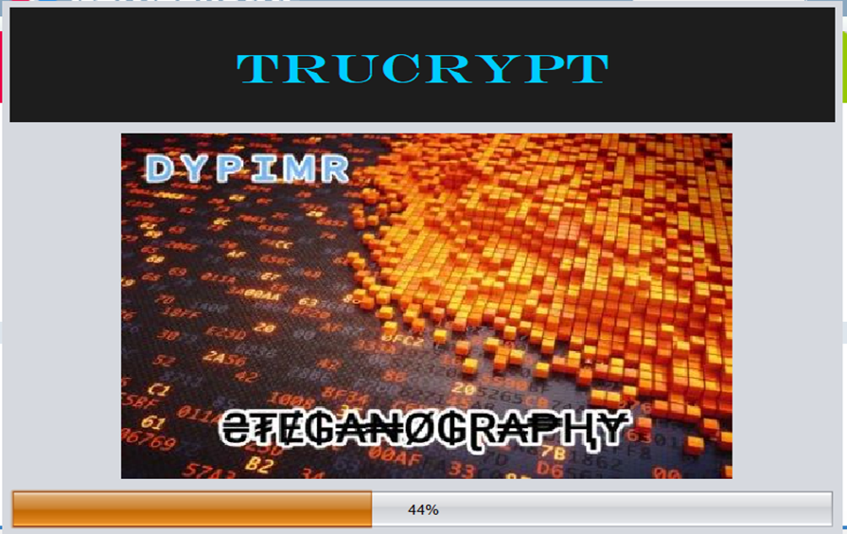

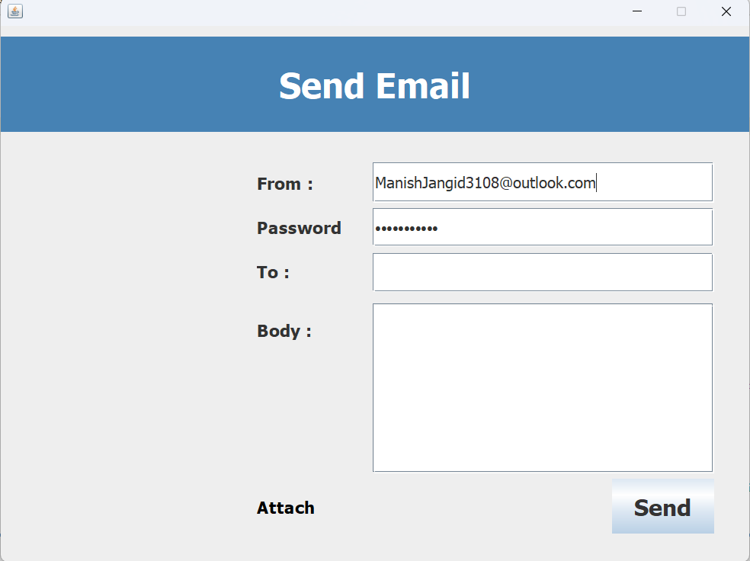

**4.3) Report**

The reports section details any reports generated by the system. It outlines report formats, contents, and the information conveyed. This comprehensive documentation helps users understand the significance of the system's output, providing insights into the hidden data extracted or embedded in images.

The Reports section outlines the generation and presentation of reports within the TruCrypt Version 1.0 system. Reports serve as a means of conveying valuable information to users and administrators, providing insights into the outcomes of operations and processes.

* **Operational Instructions Report:**

TruCrypt Version includes an Operational Instructions Report that serves as a comprehensive guide for users. This report outlines step-by-step instructions for both embedding and extracting hidden data within images. It aims to assist users in navigating the system effectively, ensuring a seamless and user-friendly experience. The Operational Instructions Report is presented in a clear and concise format, with detailed explanations of each operation and relevant screenshots for visual reference.

* **Input/Output Screens Report:**

The Input/Output Screens Report provides users with a visual representation of the graphical user interface (GUI) of TruCrypt Version 1.0. This report includes screenshots and descriptions of key input screens where users provide information, as well as output screens displaying the results of operations. The report aids users in understanding the look and feel of the application, facilitating a more intuitive interaction with the system.

* **Embedded Data Extraction Report:**

Upon successful extraction of hidden data from an image, TruCrypt generates an Embedded Data Extraction Report. This report provides detailed information about the extracted data, including the content, timestamp of extraction, and any relevant metadata. The report aims to ensure transparency and traceability in the extraction process, allowing users to verify the integrity and accuracy of the retrieved information.

* **Security Audit Report:**

To address security requirements, TruCrypt includes a Security Audit Report. This report provides a summary of security-related events, such as failed authentication attempts or unauthorized access to embedded data. The Security Audit Report assists administrators in monitoring potential security threats and ensures compliance with the system's security measures.

**5) System Limitations**

The System Limitations section aims to communicate specific constraints and considerations that users and administrators should be mindful of when utilizing TruCrypt Version 1.0.

* **Java Runtime Environment Dependency:**

To execute TruCrypt, users must have a Java Runtime Environment (JRE) installed on their machines. This dependency is critical for the proper functioning of the application. While JRE is widely available, users need to ensure its availability and compatibility with their operating systems. In scenarios where JRE is not present or is outdated, users may experience issues launching TruCrypt.

* **Compatibility with Operating Systems:**

TruCrypt is developed using Java, ensuring cross-platform compatibility. However, variations in operating system configurations and updates may impact the application's performance. Users are encouraged to use the latest versions of their operating systems and address any compatibility issues that may arise.

Understanding these system limitations is essential for users to make informed decisions about the use of TruCrypt Adhering to these considerations will contribute to a smoother user experience and facilitate the effective integration of the system into existing workflows.

**6) Future Enhancement**

The Future Enhancement section outlines potential areas for the improvement and expansion of TruCrypt Version 1.0. The development team envisions these enhancements to address emerging needs, technological advancements, and user expectations.

**1). Cross-Platform Mobile Application:**

To broaden the accessibility of TruCrypt , a significant future enhancement involves the development of a cross-platform mobile application. This application would extend the capabilities of TruCrypt to mobile devices, allowing users to perform steganography operations on the go. The mobile application would provide a user-friendly and portable solution, catering to users who require secure information exchange through images on their smartphones or tablets.

**2). Integration with Machine Learning Algorithms:**

An innovative future enhancement involves exploring the integration of machine learning algorithms within TruCrypt. Machine learning can be utilized to improve the system's ability to detect potential vulnerabilities, adapt to evolving security threats, and optimize steganographic processes. This enhancement aims to leverage advanced technologies to enhance the overall security and performance of TruCrypt.

**7) Conclusion**

Summarizing key findings and achievements, the conclusion emphasizes the significance of TruCrypt Version 1.0 in addressing the identified problem. It reflects on the project's success and contributions to the field of secure information exchange. The conclusion serves as a reflection on the journey, acknowledging challenges and celebrating achievements.

In conclusion, TruCrypt version 1.0 represents a successful endeavor in developing a secure and user-friendly Image Steganography system in Java. Achieving its primary objectives, the system empowers users to confidentially exchange information within images. Through iterative development and user feedback, TruCrypt has evolved to align closely with user needs. Looking forward, the system envisions future enhancements, such as advanced steganographic techniques, a cross-platform mobile application, and machine learning. Acknowledging the collaborative efforts of stakeholders, TruCrypt is committed to quality, security, and continuous improvement. As TruCrypt embarks on its release, it invites users to actively engage, provide feedback, and contribute to the ongoing evolution of a sophisticated and secure communication tool.

1. **Bibliography**

* “IEEE Standards for Software Development"
* [www.coursera.org](http://www.coursera.org)
* Java Blackbook by R.Nageswara Rao
* [www.Drawio.com](http://www.Drawio.com)
* “Introduction to Software Engineering” by Sommer Ville
* [www.geeksforgeeks.org](http://www.geeksforgeeks.org)